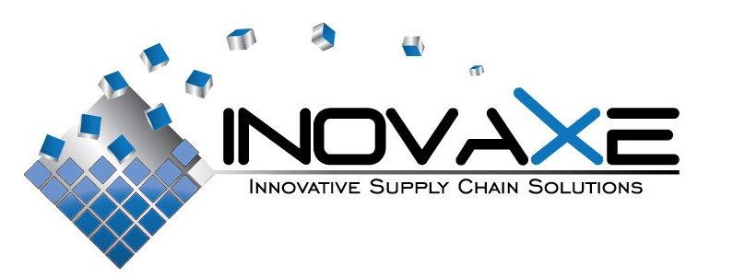

FOR IMMEDIATE RELEASE

Contact:
Inovaxe Corp.
Deerfield Beach, FL
9454.531.1363
E-mail: info@inovaxe.com
www.inovaxe.com

Don’t Miss Inovaxe’s Suitcased-Sized Kit Cart on Display at the SMTA Arizona-Sonora Expo & Tech Forum

DEERFIELD BEACH, FL — October 2010 — Inovaxe, a world leader and provider of innovative material handling and inventory control systems, will display its Suitcase-Sized Kit Cart at the upcoming SMTA Arizona-Sonora Expo & Tech Forum, scheduled to take place Wednesday, December 1, 2010 at the Fiesta Inn Resort & Conference Center in Tempe, AZ.

Continuing the Inovaxe philosophy of inventory control through single package/single location, Inovaxe will showcase the innovative Suitcase-Sized Kit Cart. The system provides non-dedicated, high-density, flexible component package storage and Web-based inventory control. The suitcase measures 22"L X 22.75"H X 15.25"W.

The Suitcase-Sized Kit Cart is designed to replace the complete SMT kiting function for the production floor and can also be utilized for inventory purposes with New Product Introduction (NPI). The system, in concert with the Web-based software, provides location, inventory accuracy and correct component validation for feeder loading and replenishment.

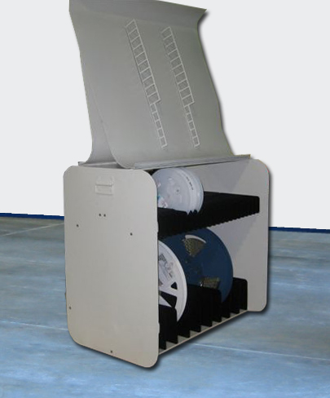
For more information about Inovaxe’s Suitcase-Sized Kit Cart, visit www.inovaxe.com.

###
About Inovaxe Corp.
Inovaxe Corporation is focused on delivering innovative production and inventory management solutions to the electronics industry. The Company’s product offering includes ambient air and MSD Material Storage Hardware (InoCart), a Supply Chain Management System (InoVision) and a Procurement Program (InoSource). For more information and a demonstration of Inovaxe products, visit www.inovaxe.com.

